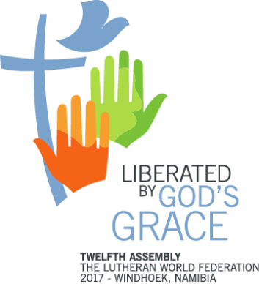
Omatala Participation Form
Twelfth Assembly

10 to 16 May 2017
Windhoek, Namibia

Member Church or Organization:
Name of contact person:
Email:
Tel. (best number to contact you by):

STANDS

1. We would like to reserve a stand Yes ☐ No ☐

The standard size of a stand is 3m x 5m. However, you may reserve a bigger stand. If so, please specify the size that you need.

2. How do you intend to use your stand?

3. The stands will be equipped with dividers, two chairs and a table. Additional furniture and equipment could be made available at a cost. If you need additional material in your stand, please list them here.

STORYTELLING

1. We have a story to tell and would like to share it: Yes ☐ No ☐

2. What is the title and theme of your story?

3. How could Assembly participants listening to your story benefit from it?

4. Name of story teller:
(Ideally, the storyteller is already a member of your delegation. If this is not the case, please note that the LWF cannot provide subsidy for their travel and accommodation):

THEME-BASED EXHIBITIONS

1. We would like to organize an exhibition: Yes ☐ No ☐

2. Title of your exhibition:

3. In less than 50 words please describe your exhibition.

4. List the materials will you need for your exhibition.

5. How much space will you need for your exhibition?

WORKSHOPS

1. We would like to organize a workshop: Yes ☐ No ☐

2. Title of workshop:

4. Link to Assembly themes:
Liberated by God’s Grace ☐
Salvation – Not for Sale ☐
Human beings – Not for Sale ☐
Creation – Not for Sale ☐

4. Duration of workshop: 30min ☐ 45min ☐ 1hr ☐

5. In not more than 100 words, describe what the workshop is about.

6. Name of workshop facilitator (Ideally, the workshop facilitator is already a member of your delegation. If this is not the case, please note that the LWF cannot provide subsidy for their travel and accommodation):

7. Will you need a projector? Yes ☐ No ☐

8. List down any other equipment, material you will need for your workshop.

Note: Please return this form to Omatala2017@lutheranworld.org no later than 31 August 2016.

